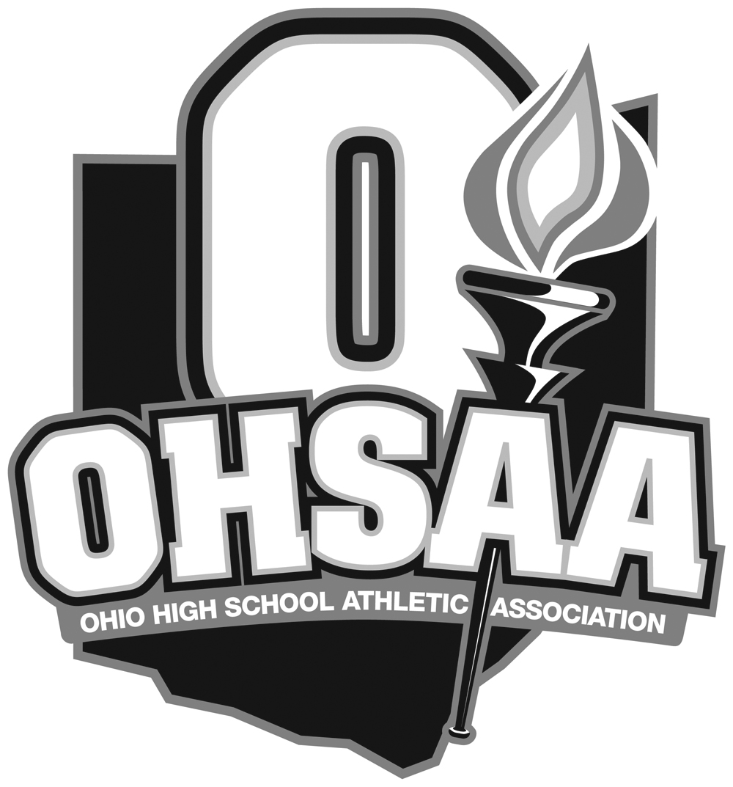
OHIO HIGH SCHOOL ATHLETIC ASSOCIATION
4080 Roselea Place, Columbus, Ohio 43214
614-267-2502
FAX 614-267-1677
www.ohsaa.org

SPECIAL PERMIT REQUEST-Waiver to Uniform

Please complete and return to Jerry Snodgrass at jsnodgrass@ohsaa.org

NFHS Baseball rules and OHSAA regulations permit schools to request a waiver to the Uniform Regulations in Rule 1-4 of the NFHS Baseball Rules Book. The waiver is granted 1 time per season for schools participating in a contest conducted for a specific cause, such as (but not limited to “Strike Out Cancer” events. This waiver, when approved will permit schools to wear an alternate jersey that may include the sponsoring event’s logo but will still require all teams to meet the ‘number requirements’ outlined in Article 3 of Rule 1-4 (all players must still wear their own unique number).

Name of School Making Request:

Type of Event/Sponsoring Organization:

Nature of Request (sponsoring agency’s logo on jersey, etc.):

Date of Contest:

Opponent:

Head Coach’s Name:

Athletic Director’s Name:

Email request to jsnodgrass@ohsaa.org or Fax to 614-267-1677 Attn: Jerry Snodgrass

